**Scroll Sense: From User Insights to AI-Powered Design**

Harsha P.

Divya Sri Bandaru

**Part 0: Data-Driven Personas**

**Data Sources**

We analyzed qualitative and quantitative data from:

* 2 in-depth interviews with university student and a professional (30-45 minutes each, fully transcribed)
* 11 survey responses with open-ended questions about social media habits, time management struggles, and reactions to intervention concepts
* Total data points: ~50+ distinct observations extracted from transcripts and survey responses

Our analysis focused on tech-comfortable users (students, young professionals) who are active across multiple social media platforms and self-aware about how excessive scrolling impacts their productivity.

**Affinity Map Summary: 5 Key Clusters**

**Cluster 1: Intention-Behavior Gap**

"I'll just check for 5 minutes" → stays 30+ minutes

Representative Quotes:

- [Interview 1] "*Once I open it, I always want to come out in like five minutes or 10 minutes, but usually just goes longer than that*"

- [Interview 2] "*That happens almost every day. Doom scrolling, that's what it's called... not knowing much time has passed*”

**Cluster 2: Existing Tools Fai**l

Too rigid (users override) or too weak (one-tap bypass)

Representative Quotes:

- [Interview 1] *"Most of the times I've finished it and I always override the logs and open the app again. It's just one button that I can click on"*

- [Interview 2] *"It kind of gets irritating after a while, so I don't use it"*

**Cluster 3: Short-Form Content Addiction**

Reels/Shorts create "just one more" infinite loops

Representative Quotes:

- [Interview 1] *"Instagram is my main concern... mainly because of the reels. Since there are only a few seconds long, it's usually very hard to come out of the loo*p"

*-* [Interview 1] *"It is also impacting my attention span to some extent*"

**Cluster 4: Context Matters**

LinkedIn for jobs ≠ Instagram Reels for entertainment

Representative Quotes:

- [Interview 1] *"I use LinkedIn a lot [for jobs]... I use Instagram as a means of entertainment"*

- [Interview 1] *"It's important for me to know about what is happening around me, but also it's not like I have to spend hours in it"*

**Cluster 5: Privacy vs. Personalization**

Want personalized nudges, but only from third-party tools (not social platforms)

Representative Quotes:

- [Interview 1] *"I wouldn't prefer the social media app to read my calendar or deadlines... BUT if the third party app... I don't really have any problem with sharing my information to it"*

- [Interview 2] *"If the message is personalized, I would not mind it"*

**Persona Set**

**Persona 1**: Graduate Student - The Guilt-Cycle

Demographics:

* Age: **
* Occupation: Graduate student with TA responsibilities
* Location: University campus
* Tech proficiency: High (iPhone user)

Goals:

* Complete assignments and TA grading on time
* Use LinkedIn productively for job searching
* Stay connected with friends through Instagram
* Maintain focus during study sessions in the library

Needs:

* Gentle interventions that help her honor her 5-10 minute intentions
* Different treatment for productive LinkedIn use vs. entertainment Instagram
* Visual cues that escalate gradually without forcing hard stops
* Personalized reminders from third-party tools (not social media platforms)

Frustrations:

* Opens Instagram for "just 5 minutes" but consistently stays 30+ minutes
* Instagram Reels are impossible to stop, "hard to come out of the loop"
* iPhone screen time limits are too easy to bypass with one button tap
* Feels guilty after scrolling, which makes focusing on work even harder
* Generic time limits punish job searching on LinkedIn same as mindless Reels

Context & Constraints:

* Balances TA work, classes, assignments, and job applications
* Uses phone during study breaks, which turn into extended scrolling sessions
* Has tried and abandoned iPhone screen time features
* Experiences vicious cycle: scroll → guilt → can't focus → more scrolling

Technology Habits:

* Primary platforms: Instagram (Reels), LinkedIn (job search), Snapchat
* Device: iPhone with screen time enabled but frequently overridden
* Usage pattern: Opens Instagram intending 5-10 minutes, stays 30+ minutes
* Daily usage: 2-3 hours (intended: 30-60 minutes)

**Justification: Traceability to Affinity Clusters:**

This persona is derived from Interview 1 participant and represents the intersection of all five affinity clusters.

* Cluster 1 (Intention-Behavior Gap) forms her core struggle, the verbatim quote "Once I open it, I always want to come out in like five minutes or 10 minutes, but usually just goes longer than that" directly defines students behavior of setting clear 5-10 minute intentions but consistently overshooting to 30+ minutes.
* Cluster 3 (Short-Form Content Addiction) explains why this happens specifically on Instagram: "Instagram is my main concern... mainly because of the reels. Since there are only a few seconds long, it's usually very hard to come out of the loop", making Reels her primary platform struggle.
* Cluster 2 (Existing Tools Fail) shaped her technology habits: "Most of the times I've finished it and I always override the logs and open the app again. It's just one button that I can click on" shows the student tried iPhone screen time but the one-tap override makes it meaningless.
* Cluster 4 (Context Matters) created her need for context-aware tools because "I use LinkedIn a lot [for jobs]... I use Instagram as a means of entertainment", student resents blanket limits that treat productive job searching the same as mindless Reels.
* Cluster 5 (Privacy vs. Personalization) informed her trust model: student explicitly stated "I wouldn't prefer the social media app to read my calendar" but "if the third party app... I don't really have any problem with sharing my information to it," making her want personalized interventions only from independent tools.
* Her post-scroll guilt cycle and preference for "mild blurring where I can't really comprehend the reel, but it allows me to think" provide additional design requirements.

Every element of Graduate student traces directly to Interview 1 quotes across all five clusters.

**Persona 2**: Daily Doom Scroller Professional

Demographics:

* Age: **
* Occupation: Working professional (office meetings + work tasks)
* Location: Urban area (hybrid work setting)
* Tech proficiency: High (iPhone user)

Goals:

* Stay productive during workday without doom scrolling
* Use LinkedIn for professional networking and updates
* Stay informed through Reddit (life hacks, daily tips)
* Maintain social connections through Instagram, Facebook, Snapchat

Needs:

* Awareness of cumulative daily time spent across all sessions
* Interventions that work consistently without becoming "irritating"
* Personalized messages that feel relevant, not generic
* Consistent settings across work hours and personal time

Frustrations:

* Loses complete track of time while scrolling—happens "almost every day"
* Opens social media for quick check, stays much longer than intended
* iPhone screen time alerts became annoying background noise, so disabled them
* Doom scrolling is a daily pattern professional intellectually recognizes but can't break

Context & Constraints:

* Busy work schedule with meetings and deadlines
* Uses multiple platforms for different purposes (professional, social, informational)
* Checks phone first thing in morning and throughout day
* Values tools that don't change behavior between work and rest time

Technology Habits:

* Primary platforms: LinkedIn (professional + mini games), Reddit (life hacks), Instagram, Facebook, Snapchat
* Device: iPhone with screen time features disabled due to irritation
* Usage pattern: "Quick checks" that extend into long sessions with complete time-blindness
* Daily pattern: Doom scrolling "almost every day"
* Daily usage: 2-4 hours (loses track of cumulative time)

**Justification: Traceability to Affinity Clusters:**

Professional is derived entirely from Interview 2 participant and embodies Clusters 1, 2, 4, and 5.

* Cluster 1 (Intention-Behavior Gap) defines his daily pattern through his exact words: "That happens almost every day. Doom scrolling, that's what it's called... not knowing much time has passed"—making daily time-blindness his core struggle rather than guilt cycles.
* Cluster 2 (Existing Tools Fail) explains why he completely abandoned screen time features (unlike student who overrides them): "It kind of gets irritating after a while, so I don't use it"—representing the "too rigid" failure mode where repeated generic alerts became annoying background noise he actively disabled.
* Cluster 4 (Context Matters) shaped his multi-platform usage: "I use LinkedIn for its features like mini games... updates from companies, peers, colleagues... Reddit for life hacks"—showing diverse purposes across platforms. However, unlike student, professional quote "I would say it should be all in the same for everything that I do because even when I'm resting, I need to be productive" reveals he prefers consistent daily limits rather than context-switching settings.
* Cluster 5 (Privacy vs. Personalization) informed his openness to personalization: "If the message is personalized, I would not mind it" and his comfort with calendar integration. His preference for cumulative daily tracking—"I would prefer to have a set amount of time like after two hours in the entire day, it should start blurring"—provides specific design direction.

Working professional demographics, morning phone-checking routine, and meeting schedule all come verbatim from Interview 2's opening context.

**Part 1: Mockup**

**List of AI Features Based on Personas**

**Feature Overview**

Scroll Sense is a Chrome extension that helps users manage social media time through AI-powered personalized interventions. Based on our affinity mapping and persona research, we identified features that address the intention-behavior gap, platform context differences, and the need for non-irritating interventions.

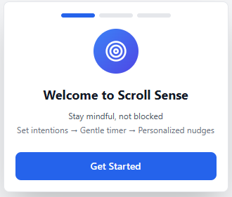

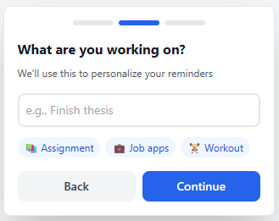

**Core Features**

**Feature 1: Session Intent Prompt**

What it does:

When a user opens Instagram, LinkedIn, or Reddit, a modal overlay appears asking: "What's your goal for this session?"

User Options:

* Quick check (5 min)
* Specific task (15 min)
* Just browsing (30 min)
* Skip for now

Persona Mapping:

* Student (Cluster 1: Intention-Behavior Gap): "Once I open it, I always want to come out in like five minutes or 10 minutes, but usually just goes longer than that" → Makes implicit intention explicit and anchors behavior to concrete commitment
* Professional (Cluster 1: Intention-Behavior Gap): Helps with time-blindness by establishing clear session goals upfront

Design Rationale:

Users already set mental time limits but fail to honor them. By making intentions explicit at entry, we create accountability and enable personalized interventions based on their actual goals, not arbitrary limits.

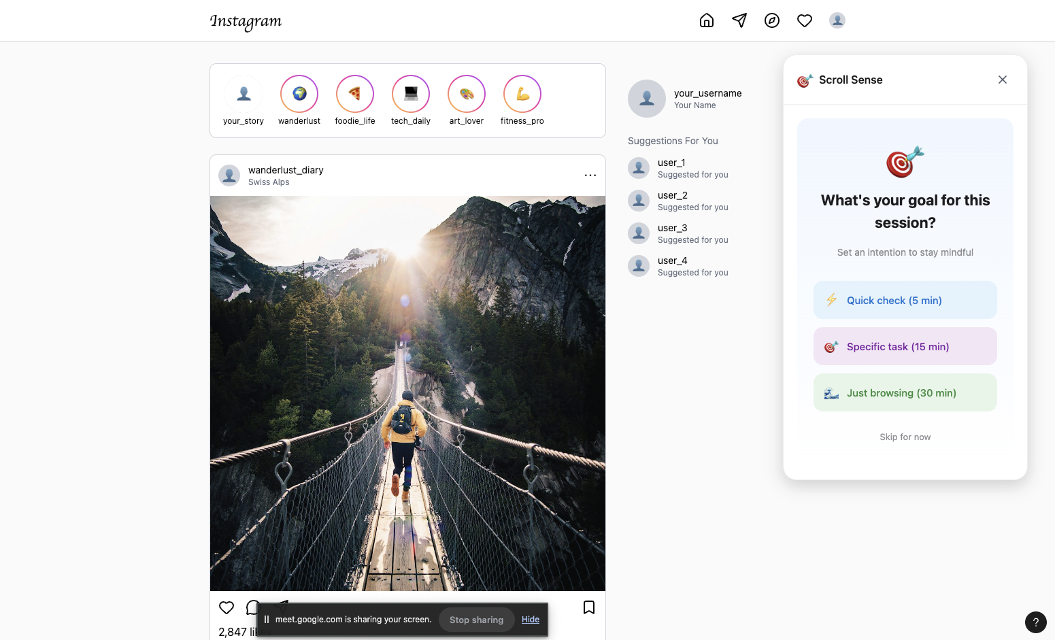

**Feature 2: Progressive Blur Timer**

What it does:

After the user's stated time limit expires, the screen gradually blurs over 5 minutes (10% → 50% opacity) while a timer overlay displays actual vs. intended time.

Behavior:

* Blur starts at user's selected time (5, 15, or 30 minutes)
* Intensity increases progressively, not instantly
* Overlay shows: "You planned: 5 min | You've been here: 12 min"
* Two action buttons: "Done for now" | "Continue 10 more min"

AI Component: Adaptive timing operates on two levels:

* Explicit Intent-Based: Uses the user's stated goal from the Session Intent Prompt (5, 15, or 30 minutes) rather than arbitrary platform defaults
* Pattern Learning (if user skips intent): If the user selects "Skip for now," the system tracks their typical session lengths over time. After collecting baseline data (5+ sessions), it suggests personalized defaults: "Most people on Instagram stay about 12 minutes. We've noticed you typically spend 18 minutes. Want to set that as your default?" This leverages both individual behavioral patterns and aggregated anonymized usage data to recommend realistic, personalized time limits.

Persona Mapping:

* Student (Cluster 2: Existing Tools Fail + Cluster 7: User Control): "I would prefer a mild blurring where I can't really comprehend the reel, but it allows me to think... if it goes completely blank, I will definitely try to override it" → Progressive blur provides awareness without forcing hard stop
* Professional (Cluster 2: Existing Tools Fail): "It kind of gets irritating after a while, so I don't use it" → Gradual escalation is less annoying than sudden alerts

Design Rationale:

Rather than forcing generic 30-minute limits that feel arbitrary, the AI learns what's realistic for each user and offers data-driven suggestions. This respects user autonomy (they can accept or modify) while providing intelligent defaults based on actual behavior patterns.

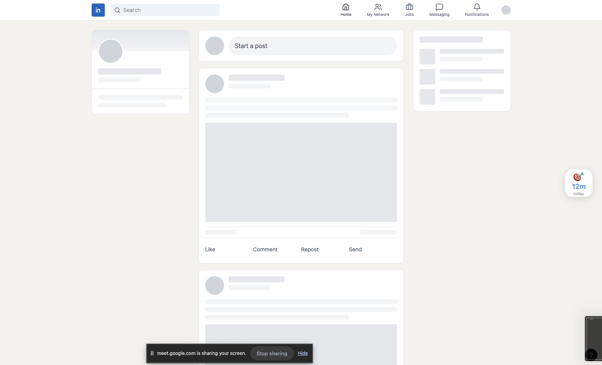

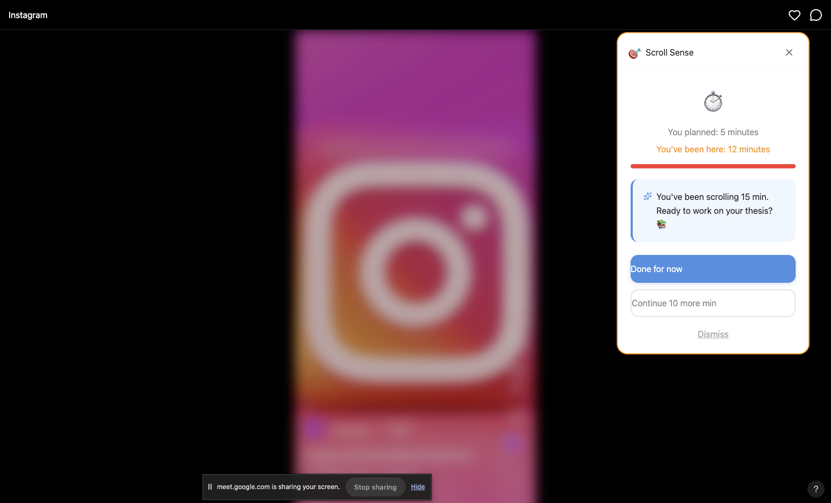

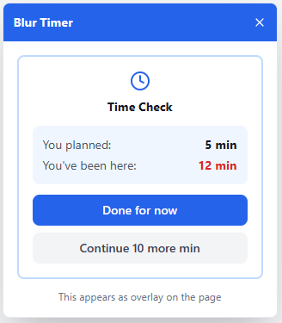

**Feature 3: AI-Powered Personalized Nudges**

What it does:

When the blur activates, Claude API generates a contextual, supportive message based on the user's personal goals.

Behavior:

Uses goals entered during onboarding (e.g., "Finish thesis," "Apply to 5 jobs")

API generates a personalized message: "You've been scrolling 15 min. Ready to work on your thesis? 📚"

Tone is warm, non-judgmental, encouraging

Message appears in blur overlay card

AI Component:

Claude API prompt: "Generate a supportive, non-judgmental reminder for a student who planned to scroll {intended_time} minutes but has been scrolling {actual_time} minutes. Their current goal is: {user_goal}. Keep the message under 20 words, with a warm and encouraging tone."

Persona Mapping:

* Student (Cluster 5: Privacy vs. Personalization): Wants personalized reminders tied to her actual commitments (thesis, TA work) but only from third-party tools
* Professional (Cluster 5: Privacy vs. Personalization): "If the message is personalized, I would not mind it" → Personalization increases effectiveness vs. generic "stop scrolling" warnings
* Both (Cluster 6: Privacy): "I wouldn't prefer the social media app to read my calendar... BUT if the third party app... I don't really have any problem with sharing my information to it" → Independent tool (not platform) accessing goals builds trust

Design Rationale:

Generic alerts become background noise. AI-generated messages that reference the user's actual goals feel supportive rather than nagging, dramatically improving intervention acceptance.

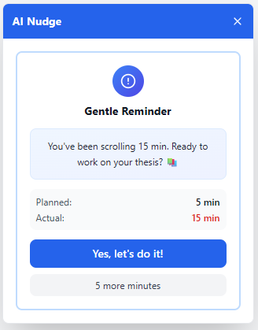

**Feature 4: Platform Detection & Custom Limits**

What it does:

Automatically applies different time thresholds based on platform usage patterns, with user customization.

Default Settings:

* Instagram: 10 minutes (strict - Reels addiction)
* LinkedIn: 30 minutes (relaxed - professional networking)
* Reddit: 15 minutes (moderate - mixed educational/entertainment)

Behavior:

* Detects platform via URL
* Loads platform-specific timer settings
* User can customize limits in Settings

AI Component:

Smart defaults based on research findings about platform purposes, with machine learning potential to adapt to individual usage patterns over time.

Persona Mapping:

* Student (Cluster 4: Context Matters): "I use LinkedIn a lot [for jobs]... I use Instagram as a means of entertainment" → Different limits respect productive vs. mindless use
* Professional (Cluster 4: Context Matters): "It's important for me to know about what is happening around me, but also it's not like I have to spend hours in it" → Recognizes legitimate value while preventing excess

Design Rationale:

One-size-fits-all solutions fail because they ignore context. Users resent tools that punish productive LinkedIn job searching the same as mindless Instagram Reels. Platform-specific defaults show the tool understands their needs.

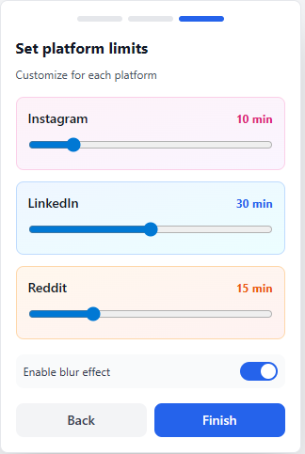

**Feature 5: Daily Cumulative Tracking**

What it does:

Tracks total social media time across all platforms and sessions throughout the day.

Behavior: Extension badge shows: "2h 15m today"

Dashboard in popup displays breakdown by platform:

* Instagram: 1h 20m (60%)
* LinkedIn: 35m (25%)
* Reddit: 20m (15%)

When opening the app after significant daily usage, intent prompt adjusts: "You've spent 2h today already. Try a shorter session?"

Resets at midnight

AI Component: Adaptive prompting based on cumulative daily usage patterns.

Persona Mapping:

* Professional (Cluster 1: Intention-Behavior Gap + Cluster 8: Daily Patterns): "That happens almost every day. Doom scrolling, that's what it's called... not knowing much time has passed" + "I would prefer to have a set amount of time like after two hours in the entire day, it should start blurring" → Addresses daily time-blindness with cumulative awareness
* Professional preference: Wants consistent daily limits, not just per-session tracking

Design Rationale:

Doom scrolling is a daily pattern, not occasional. Per-session limits miss the big picture, users might stay within 15-minute sessions but open apps 15 times per day. Daily tracking provides essential context for habit awareness.

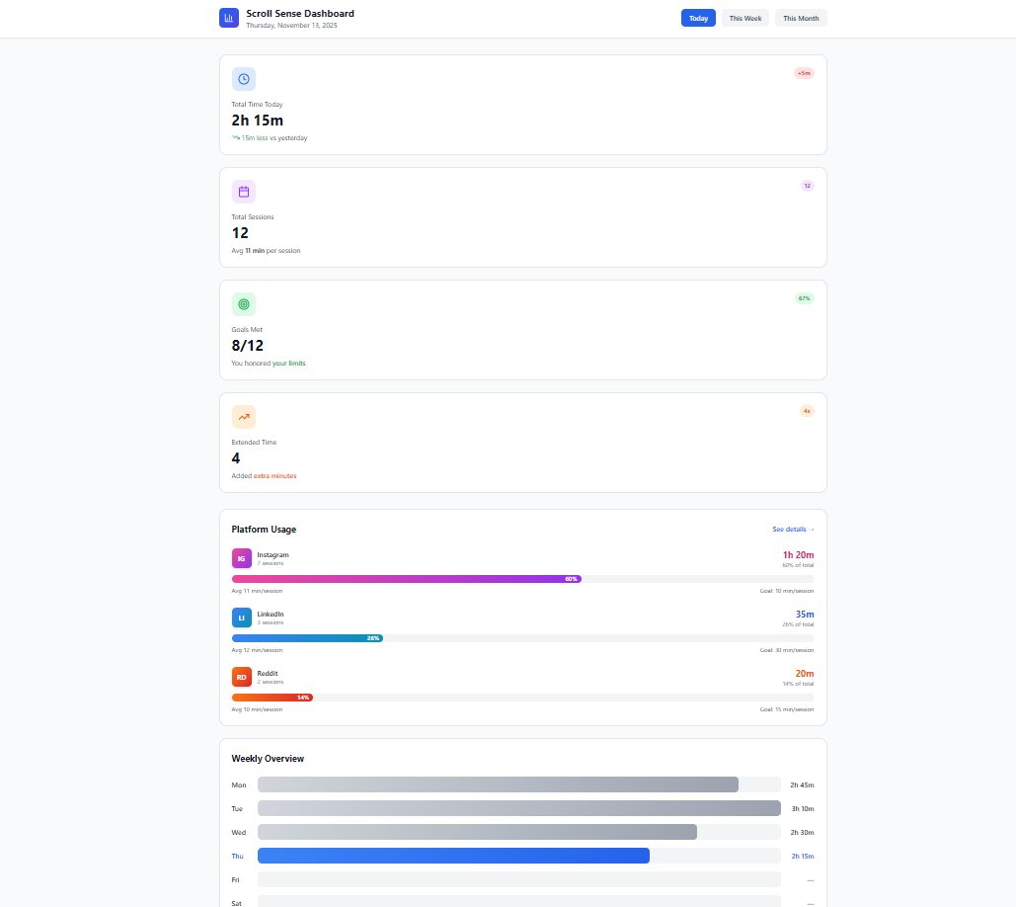

**Feature 6: Settings & Customization**

What it does:

Comprehensive settings page accessible from extension popup.

Settings Sections:

1. Personal Goals

Edit goals entered during onboarding

Add/remove/modify goals (up to 3)

Preview AI message generation

1. Platform Time Limits

Three platform cards with sliders:

* Instagram (separate for Reels vs. Feed if time permits)
* LinkedIn
* Reddit

Range: 0-60 minutes

Visual slider with color zones: green (0-15) → yellow (15-30) → red (30-60)

1. Intervention Preferences

Toggle: Enable/disable blur effect

Slider: Blur intensity (mild 30% → strong 70%)

Dropdown: Message tone

🌟 Encouraging ("You've got this!")

😊 Neutral ("Time check")

📋 Direct ("Back to work")

1. Daily Goals

Set daily total limit (optional)

Toggle: Show badge with today's time

Button: "Reset today's stats"

1. Privacy & Data

Explanation: "All data stored locally on your device"

Button: "Export my data" (download JSON)

Button: "Clear all data"

AI Component:

Tone selection affects Claude API prompt engineering; adaptive settings influence intervention frequency and style.

Persona Mapping:

* Student (Cluster 7: User Control): "People use social media for different reasons and different timings. Having control... giving control to the user is very useful" → Extensive customization prevents tool abandonment
* Professional (Cluster 2: Existing Tools Fail): "It kind of gets irritating after a while" → Ability to adjust intervention style prevents habituation and annoyance
* All personas (Cluster 5: Privacy): "I wouldn't prefer the social media app to read my calendar" → Transparency about local-only data storage builds trust

Design Rationale:

Users have different preferences (Ananya wants context-aware; Rohan wants consistent). Customization allows the tool to adapt to individual needs rather than forcing one approach. Transparency about privacy addresses Cluster 6 concerns about third-party data access.

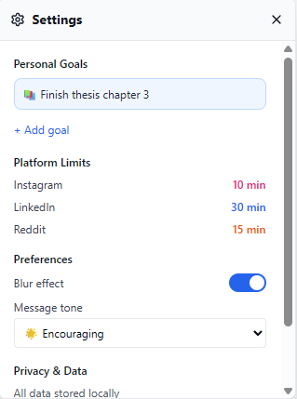

**Features We Intentionally Excluded**

Based on our research findings, we will NOT include:

* Hard app blocking: Cluster 2 showed "Most of the times I've finished it and I always override the logs" → Users bypass or abandon hard blocks
* Shame-based messaging: Cluster 5 revealed guilt cycles harm productivity → Tool uses encouraging, not accusatory tone
* Platform-integrated solution: Cluster 6 showed "I wouldn't prefer the social media app to read my calendar" → Privacy concerns with platforms accessing data
* Generic daily time limits (without context): Cluster 1 and 4 showed these ignore intentions and punish productive use
* Repetitive identical alarms: Cluster 2 showed "It kind of gets irritating after a while, so I don't use it" → Generic repeated alerts cause tool abandonment

## 

## 

## 

## **Part 2: User Storyboard**